Մասերի համեմատումը
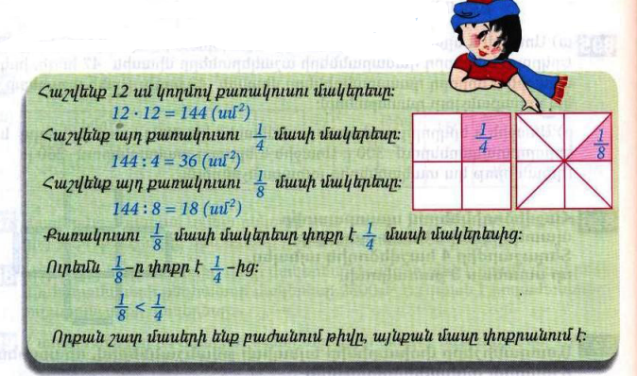
Դասարանական առաջադրանքներ
1․ Համեմատի՛ր։
$$\frac{1}{5}<\frac{1}{4}$$

$$\frac{1}{12}>\frac{1}{16}$$

$$\frac{1}{123}>\frac{1}{124}$$

$$\frac{1}{18}=\frac{1}{18}$$
2․ Թվերը դասավորիր
աճման կարգով․
$$\frac{1}{16},\frac{1}{143},\frac{1}{9},\frac{1}{24},\frac{1}{142},\frac{1}{14} \frac{1}{143}<\frac{1}{142}<\frac{1}{24}<\frac{1}{16}<\frac{1}{14}<\frac{1}{9}$$

3․ 8400լ տարողությամբ երկու ջրավազաններից լցված են առաջինի $\frac{1}{4}$մասը և երկրորդի $\frac{1}{5}$ մասը։ Ջրավազաններից որու՞մ ավելի շատ ջուր կա։ Որքա՞ն է նրանցում եղած ջրի քանակների տարբերությունը։ առաջինի մեջ ավելի կա 8400:4=2100 8400:5=1680 2100-1680=420
4․ Ջրավազանում կար 1250լ ջուր, որը կազմում է նրա տարողության $\frac{1}{4}$մասը։ Որքա՞ն է այդ ջրավազանի տարողությամբ։ 1250x4=5000
5․ Գտի՛ր անհայտ բաղադրիչը։
4928+2142=7070
2014=3535-1521
6․ Ավտեմեքենան առաջին օրը գնաց 80կմ/ժ արագությամբ 5ժ, իսկ երկրորդ օրը՝ 85կմ/ժ արագությամբ 3ժ։ Որքա՞ն ճանապարհ անցավ ավտոմեքենան այդ երկու օրում։ 80x5=400 85x3=255 400+255=655
7․ Շախմատի խմբակում կա 11 տղա և 5 աղջիկ: Ամեն ամիս խմբակին միանում է 1 տղա և 3 աղջիկ: Քանի՞ ամիս անց խմբակում տղաների և աղջիկների քանակը կհավասարվի:3 ամիս
8․Ջրավազանում ջուր կարող է լցվել 2 խողովակներից: Առաջին խողովակով մեկ ժամում լցվում է 120լ ջուր, իսկ երկրորդով՝ 140լ: Քանի՞ լիտր ջուր կլցվի ջրավազանում 5 ժամվա ընթացքում, եթե խողովակները միաժամանակ բացվեն:120x5=600 140x5=700 700+600=1300
Առաջադրանքներ թեստ 5-ից
1. Քառակուսու պարագիծը 144 սմ է:Գտի´ր քառակուսու կողմի երկարությունը: 144:4=36
2. Ո՞ր դատողությունն է սխալ
- Գումարելին մեծացնելիս գումարը մեծանում է
- Նվազելին մեծացնելիս տարբերությունը մեծանում է
- 320-ից փոքր թիվը փոքր է նաև 300-ից
- 399 թիվը փոքր է 401-ից
3. Կտրեցին 15 մետր երկարությամբ ժապավենի 1/5 մասը: Քանի՞ մետր ժապավեն մնաց: 15:5=3 15-3=12
4. Տրամագրի միջոցով տրված է ընտանիքի անդամների տարիքը: Օգտվելով տրամագրում բերված տվյալներից՝ հաշվի´ր, պապիկի և տղայի տարիքային տարբերությունը:
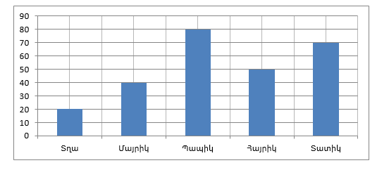 70-20=60
5. Հաշվի´ր ամենամեծ քառանիշ թվի և ամենափոքր եռանիշ թվերի տարբերությունը։9999-100=9899
6. Ուղղանկյունաձև հողամասի երկարությունը 220մ է, որը 40սմ-ով մեծ է լայնությունից: Հաշվի´ր այդ հողամասի մակերեսը:220x180=39600
7. Երկու վայրերից, որոնց միջև եղած հեռավորությունը 456 կմ է, միաժամանակ իրար ընդառաջ շարժվեցին երկու ավտոմեքենա, նրանցից մեկի արագությունը 72 կմ/ժ էր: Ի՞նչ արագությամբ էր շարժվում երկրորդ ավտոմեքենան, եթե ավտոմեքենաները հանդիպեցին շարժվելուց 3 ժամ հետո:72x3=216 456-216 =240 240:3=80
Տնային առաջադրանքներ
1․ Համեմատի՛ր։
$$\frac{1}{7}>\frac{1}{9}$$

$$\frac{1}{28}<\frac{1}{16}$$

$$\frac{1}{143}=\frac{1}{143}$$

$$\frac{1}{19}>\frac{1}{27}$$
2․ Թվերը դասավորիր
նվազման կարգով
$$\frac{1}{12},\frac{1}{216},\frac{1}{8},\frac{1}{9},\frac{1}{220},\frac{1}{16} \frac{1}{8},\frac{1}{9},\frac{1}{12},\frac{1}{16},\frac{1}{216},\frac{1}{220}$$
3․ Մարդատար ավտոմեքենան 1 ժամում անցավ 240կմ երկարությամբ ճանապարհի $\frac{1}{3}$մասը, իսկ բեռնատարը՝ $\frac{1 }{4}$ մասը։ Ավտոմեքենաներից ո՞րն է 1 ժամում ավելի շատ ճանապարհ անցել։ Քանի՞ կիլոմետր ճանապարհ դեռ պիտի անցնի նրանցից յուրաքանչյուրը։ Մարդատար ավտոմեքենա=240:3=80 240-80=160 բեռնատար=240:4=60 240-60=180 մարդատար ավտոմեքենան ավելի է անցել մեկ ժամում:
4․ Ջրավազանում կար 2400լ ջուր, որը կազմում է նրա տարողության $\frac{1}{3}$ մասը։ Դեռ որքա՞ն ջուր կարելի է լցնել այդ ջրավազանը։ 2400x3=7200 7200-2400=4800
5․ Գտի՛ր անհայտ բաղադրիչը։
21021=18018+3003
40835-8507=32328
6․ Երբ Հայկն իր գումարից 150դրամ տվեց Արային և 250դրամ՝ Գագիկին, նրանց ունեցած գումարները հավասարվեցին։ Որքա՞ն դրամ ուներ տղաներից յուրաքանչյուրը, եթե նրանք միասին ունեին 2400դրամ։ 2400:3=800
800+150+250=1200
800-250=550
800-150=650

